**Project title:** SAHK Movies & Songs

**Project description:**

* The user will be able to search for videos/ songs and radio stations. The website will have a function that allows the user to search for videos/ songs on Youtube/ Spotify and for radio stations.
* The website will by default display trends on Youtube/ Spotify/ radio. However, if the customer looks for “fluffy cats” selecting Youtube, Youtube container will display the top 3 results for “fluffy cats” on Youtube.
* There is also a News section (which collects top articles from news websites).

**User story:** As a user who loves movies and songs I want to have all the music at one place, so that I don’t have to open many different websites at a time to have a great time while listening to my favorite songs.

**Wireframe or sketch of the design** (below is a rough draft):

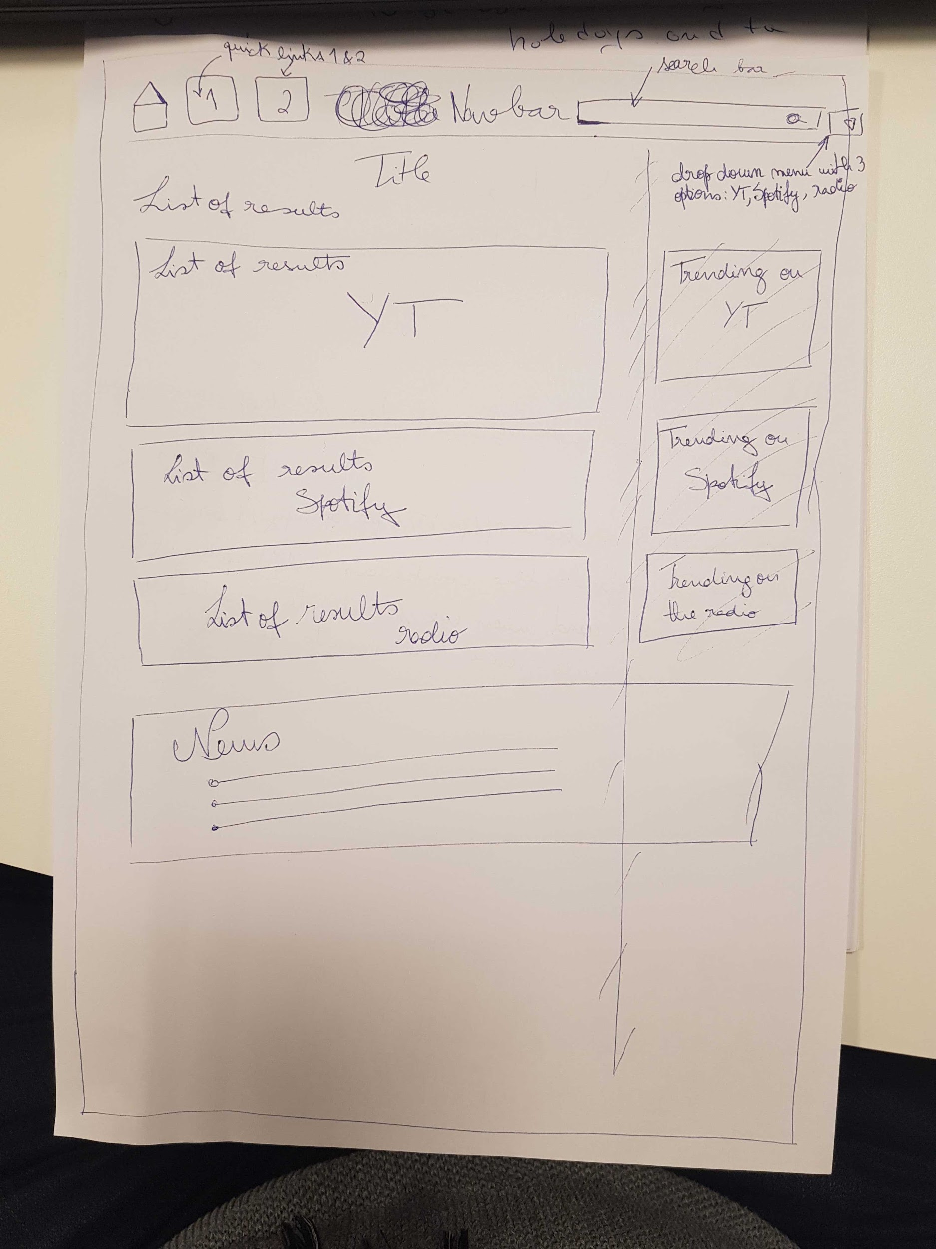

**APIS to be used:** Youtube, Spotify, Shoutcast.

**Rough breakdown of tasks:**

* Frontend: Hristina and Szilard
* Backend: Karan and Ana

**//Hristina**

**Topics to discuss and create actionable tasks on Sat:**

1. HTML skeleton - grid structure (Bootstrap?)
2. Placement of the main blocks, content

2.1. Youtube

2.2. Spotify

2.3. Radio

1. Placement of the secondary blocks, content
2. Content - what is our main content, what do we want to display to the user (what do we get from APIs)?

4.1. Youtube

4.2. Spotify

4.3. Radio

1. Bars & buttons - navigation, search, buttons, what elements do we need and what we want from these?

5.1. Placement & content

1. Styling - at a later stage maybe, but what exactly?
2. Action, functionality, interaction - all in one page, do we need other html pages to redirect/display something else as information/content

6.1. What is the user experience, how the user will interact with our app, what do we provide as a value?

We will use: HTML, CSS, JS, jQuery, what else?? Libraries?

**Tasks acc to the list above:**

……..